HOME WORK

Represent the following volumes as an integral and evaluate the integral.
1(a). Fig. 37. For 0≤x≤3, each face is a circle with height (diameter) 4–x meters

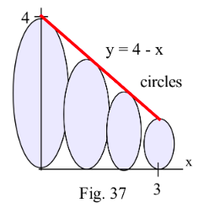

(b) Fig. 34. For 0 ≤ x ≤ 3, each face is a rectangle with base 2 inches and height 5–x inches.

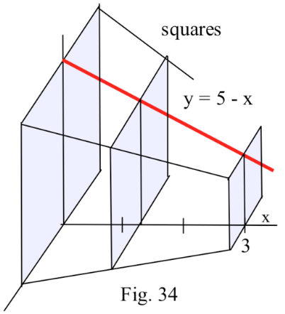

Very few functions y = f(x) lead to integrands of the form $\sqrt{1 + {\left(\frac{dy}{dx}\right)}^{2}}$ which have elementary antiderivatives. In problem(c), 1 + ${\left(\frac{dy}{dx}\right)}^{2}$ is a perfect square and the resulting arc length integrals can be evaluated using antiderivatives. Do so.
(c) $y=\frac{x^{5}}{5}+\frac{1}{12x^{3}}$ for 1 ≤ x ≤ 5.

(2). A cylindrical barrel with a radius of 1 foot and a height of 6 feet is filled with oil ($60 pounds/ft^{3}$).
(a) How much work is done pumping all of the oil over the top edge of the barrel?
(b) How much work is done pumping the top 1 foot of oil to a point 2 feet above the top of the barrel?
(c) How long will it take a 1 horsepower pump to empty the top 3 feet of oil over the top edge of the barrel?

In problem 3, sketch the region bounded between the given functions on the interval and calculate the centroid of each region (use Simpson's rule with n = 20 if necessary). Plot the location of the centroid on your sketch of the region.
$\left(3\right) y = x and the x–axis for 0 ≤ x ≤ 3.$

